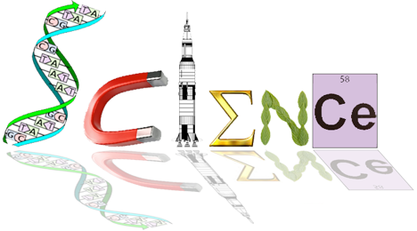**ATHBY YEAR 12 ATAR HUMAN BIOLOGY**

**Task 3: Response to Infection**

**Task Weighting – 7% Task Type – Response**

**Part A** You have one week to research the topic and complete notes. You **may not** use these notes for Part B. (4 marks)

Topic – Infections

Specific and non-specific defence and response mechanisms to infection

Specific artificial methods of preventing and responding to infection

Ensure you REFERENCE your sources for your notes. (1 mark)

**Part B:** In class validation – examination-style extended answer questions.

**Conditions:** Test conditions

**Time for task**: 40 minutes